**OpenAIRE检索证明**

**OpenAIRE Retrieval/ Search Certificate**

This is to certify that the paper

Title: *Canton Embroidery and the Maritime Silk Road: The Fusion of Intangible Cultural Heritage Traditions and Modern Values*

by Jing Tian of Faculty of Foreign Languages, Guangdong Baiyun University

has been **published** in the journal *Communication across Borders: Translation & Interpreting* (ISSN 2766-791X), with the permanent link: <https://jhkpress.com/index.php/cabti/article/view/119>

and **indexed** by OpenAIRE, with the permanent link:

<https://explore.openaire.eu/search/publication?pid=10.5281%2Fzenodo.14294393>

Attached below are the screenshot of the OpenAIRE search result and the pdf file of the paper’s page on the OpenAIRE’s official website.

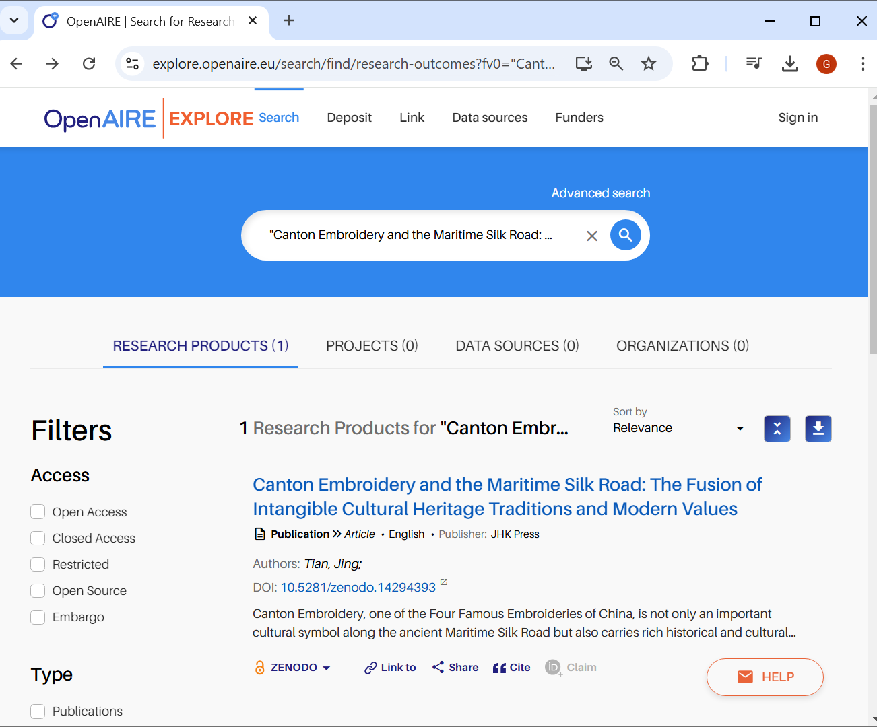

www.jhkpress.com

JHK PRESS, USA Date: 12/07/2024